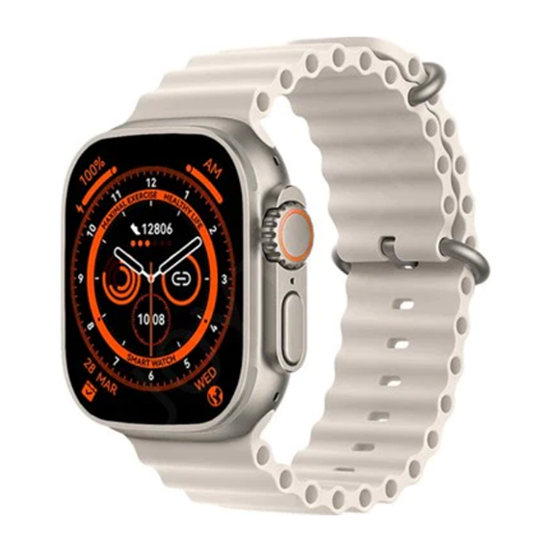

X8 Ultra Smart Watch 49 mm Ocean Straps Space Gold Color Full Screen HD Display Bluetooth Calling All Sports Mood

* Brand: Wear Teck.
* New Box Pack
* 100% Original
* 1 Week Checking Warranty
* New Latest Model
* 8 Ultra Variant
* 1.99 inch Edge Display Screen
* IPS Full HD Touch Screen
* Always on Display Option
* Raise to Wakeup Screen
* Water Resistant
* Easy Bluetooth Connection
* Android & iOS Connectivity
* Android 5.0 +, IOS 9.0 +
* 1 Day Battery Timing Connection
* 1 Week Battery Backup on Standby
* Call Receiving Option
* Call Dialing Option
* Mobile Contact Synchronization
* What’s App & Text Messaging Notification

SMART WATCH